## Tech stack

### Data analysis



* Excel

### Data visualisation



* Tableau

## Skills showcased

Demonstrated 7 key skills through this micro experience

1. Spreadsheet Skills: Excel skills were utilized for data analysis, cost structure calculations, and refining partner profitability assessments.
2. Data Transformation: Data transformation skills were applied to standardize cost structures, adjust fuel costs, calculate EMIs, and optimize partner profitability.
3. Exploratory Data Analysis: Exploratory data analysis (EDA) was performed to identify clusters, visualize overpayments, and assess partner profitability.
4. Data Visualisation: Data visualization skills were employed to create Tableau visualizations, interactive dashboards, and analyze partner payouts, clusters, and overpayments in the project.
5. Problem Solving: Problem-solving skills were utilized to identify causes of high variance, assess partner profitability, and propose solutions for optimizing partner payouts.
6. Storytelling with Data: Storytelling with data skills were applied to effectively communicate project findings, insights, and recommendations through visualizations, dashboards, and documentation.
7. Business Acumen: Business acumen skills were utilized to understand the financial implications, identify cost-saving opportunities, and align partner payouts with the organization's budget.

## Problem scenario

### Situation

**Business Situation:** Excessive payments to last-mile delivery partners: 50% over the budget, posing financial burden for the logistics company.

**Business Process:** Optimization of partner payouts to ensure financial efficiency and align with allocated budgets.

**Importance**: Aligning partner payouts with budgets to ensure financial efficiency and the success of the organization.

### Complication

**High Variance in Partner Payouts:** High variance in partner payouts, identified through data analysis, highlights the need to align actual payouts with budget allocations for financial efficiency.

**Partner Profitability Challenges:** Partner profitability challenges arise as many partners operate at a loss despite high payouts, necessitating measures to ensure sustainable profitability.

**Payout-Cost Balancing Difficulty**: The project faces challenges in achieving a balance between partner payouts and standardized cost structures to ensure fair and efficient financial outcomes.

### Business impact

**Improved Financial Efficiency:** The project optimizes partner payouts, reducing overpayments and aligning them with the allocated budget, leading to improved financial efficiency.

**Enhanced Partner Profitability:** By identifying and addressing challenges in partner profitability, the project ensures partners operate at sustainable levels, fostering stronger relationships and long-term success.

**Cost Savings and Budget Optimization:** Standardizing cost structures and refining payout calculations enable cost savings, allowing for better budget allocation and resource optimization within the organization.

## Objectives

Success looks like aligned payouts, reduced variances, and sustainable partner operations achieved through optimized last-mile delivery partner payouts.

## Approach

1. **Problem approach**
   1. **Data Analysis and Visualization:** Analyzing partner payout data using Excel and creating visualizations in Tableau to identify patterns and clusters.
   2. **Identifying Causes of High Variance:** Investigating factors contributing to the significant differences between target and actual payouts, such as commercial structures and validation systems.
   3. **Determining Partner Profitability:** Assessing partner profitability by analyzing payouts, commercials, and loads delivered to understand their financial performance.
   4. **Standardizing the Cost Structure:** Making adjustments to cost calculations in Excel, such as zeroing fuel costs and considering vehicle capacity, to improve accuracy and fairness.
2. **Analytical approach**
   1. **Budget and Payout Analysis:** Evaluating the allocation of funds and examining partner payouts to ensure financial alignment.
   2. **Variances and Inconsistencies Identification:** Identifying discrepancies and irregularities in partner payout amounts compared to planned targets.
   3. **Commercial Structures Investigation:** Examining the contractual arrangements and terms governing partner payouts and identifying areas of improvement.
   4. **Partner Profitability Assessment:** Analyzing partners' financial performance and determining if they operate at a profitable level.
   5. **Cost Refinement and Standardization:** Making adjustments to cost calculations and implementing standardized methods to ensure fairness and accuracy.
   6. **Payout-Cost Balancing Strategies:** Exploring approaches to achieve a balance between partner payouts and cost optimization for sustainable financial outcomes.
3. **Insights and recommendations**
   1. Implement validation systems and standardized cost structures to curb overpayments and ensure fairness in partner payouts.
   2. Explore strategies to improve partner profitability, such as incentivizing higher load delivery and adjusting payout rates based on cost structure.
4. **Solution implementation and monitoring**
   1. Roll out the standardized cost structure and validation systems, closely monitoring their effectiveness in reducing variances and improving partner profitability.
   2. Continuously monitor partner performance, load delivery, and cost metrics through the interactive dashboard in Tableau for ongoing optimization of payouts.
5. **Communication** 
   1. Develop a comprehensive documentation summarizing the project methodology, findings, and recommendations, ensuring clear communication and knowledge sharing.

## Impact created

Using the commercial calculator for partners in the Ahmedabad cluster had a significant business impact. It enabled accurate and efficient calculations of financial metrics, allowing for better decision-making, streamlined processes, and improved profitability. This tool helped optimize pricing strategies, negotiate deals, and ultimately maximize revenue and profitability for the partners in the Ahmedabad cluster.

## Project deliverables

**Process_overview_model**

Link: <https://github.com/aritra-18/LastMile-Payout-Optimization/blob/main/Process_overview_model.png>

Type: Excel Spreadsheet

Calculation and Comparison of the cost per kg of partner vehicles and delivery locations

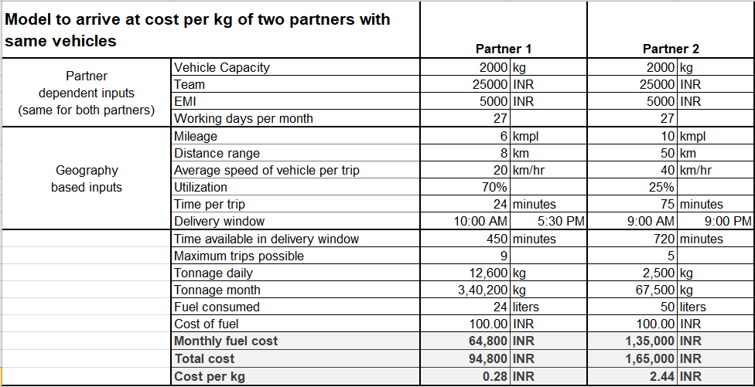

**D1_Analyzing_Excess_Payouts: Actual vs Budget Payouts Analysis Dashboard**

Link: <https://github.com/aritra-18/LastMile-Payout-Optimization/blob/main/D1_Actual%20vs%20Budget%20Payouts%20Analysis%20Dashboard.png>

Type: Excel Spreadsheet

Verifying partners exceeding budget through total payout comparison. Identifying overpaid clusters, branches, and partners.

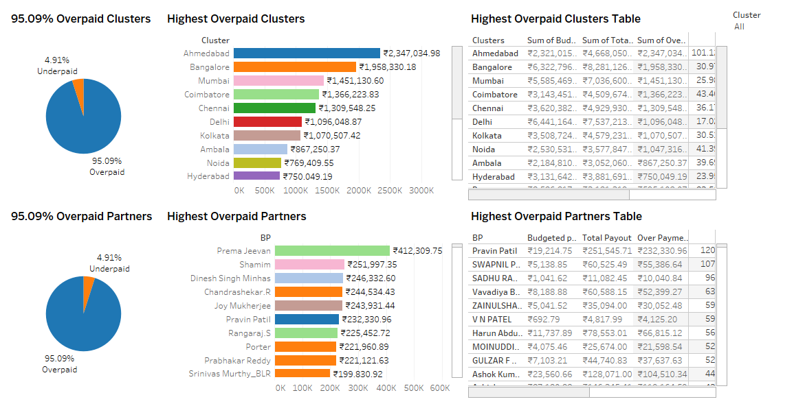

**D2_Cost_Base**

Link: <https://github.com/aritra-18/LastMile-Payout-Optimization/blob/main/D2_Cost_Base.png>

Type: Excel Spreadsheet

Calculation of cost per kg for partners' vehicles, addressing high payout variances and ensuring profitability.

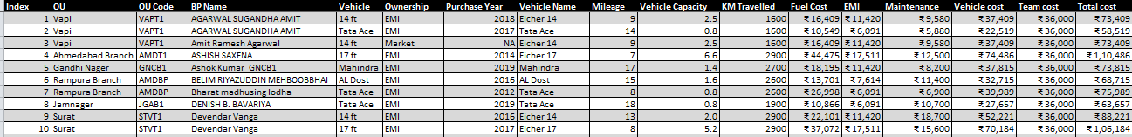

**D3_Profitability_Sample**

Link: <https://github.com/aritra-18/LastMile-Payout-Optimization/blob/main/D3_Profitability_Sample.png>

Type: Excel Spreadsheet

Calculation partners' total costs and compares them to payouts, assessing profitability and budget effectiveness.

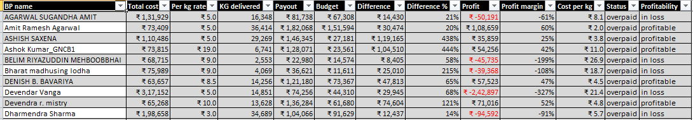

**D4_Improved_Cost_Base**

Link: <https://github.com/aritra-18/LastMile-Payout-Optimization/blob/main/D4_Improved_Cost_Base.png>

Type: Excel Spreadsheet

Adjustments and standardizations being done the cost structure of partners based on specific parameters to ensure fair and accurate calculations.

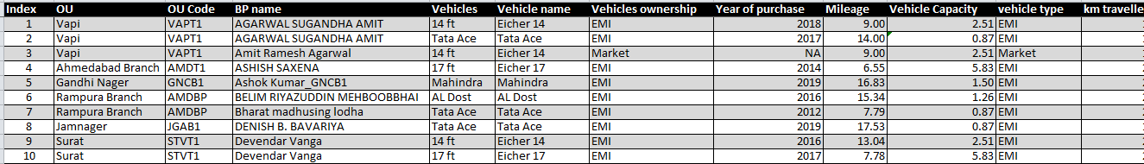

**D4_Improved_Profitability**

Link: <https://github.com/aritra-18/LastMile-Payout-Optimization/blob/main/D4_Improved_Profitability.png>

Type: Excel Spreadsheet

Rechecks done for partner profitability using the updated cost structure, providing insights into the fairness of payouts and budget allocation.

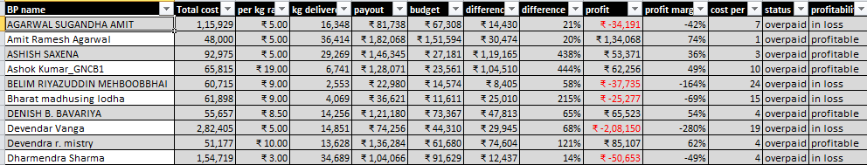

**D5_Profit_Analysis**

Link: <https://github.com/aritra-18/LastMile-Payout-Optimization/blob/main/D5_Profit_Analysis.png>

Type: Excel Spreadsheet

Exploratory Data Analysis done for the factors contributing to the current profitability of partners, including load delivered, per-kg payouts, cost per kg, and partner capacity utilization.

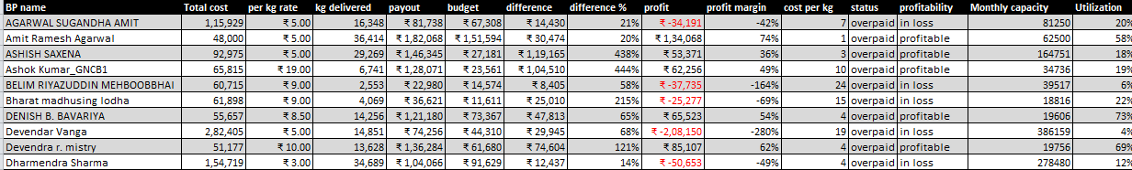

**D6_Commercials Calculator**

Link: <https://github.com/aritra-18/LastMile-Payout-Optimization/blob/main/D6_Commercials%20Calculator.png>

Type: Excel Spreadsheet

Created a commercial calculator that calculates the standardized cost per kg of a partner at 80% utilization and determines the appropriate payout rate based on the profit margin input.

## 

## Things I learnt (optional)

1. The importance of data analysis and visualization in identifying patterns, clusters, and areas of concern for optimization.

2. The significance of considering both partner payouts and cost structures to achieve financial efficiency and partner profitability.

3. The value of effective communication and documentation to convey project insights, recommendations, and foster stakeholder understanding.

## Feedback received (optional)

N/A